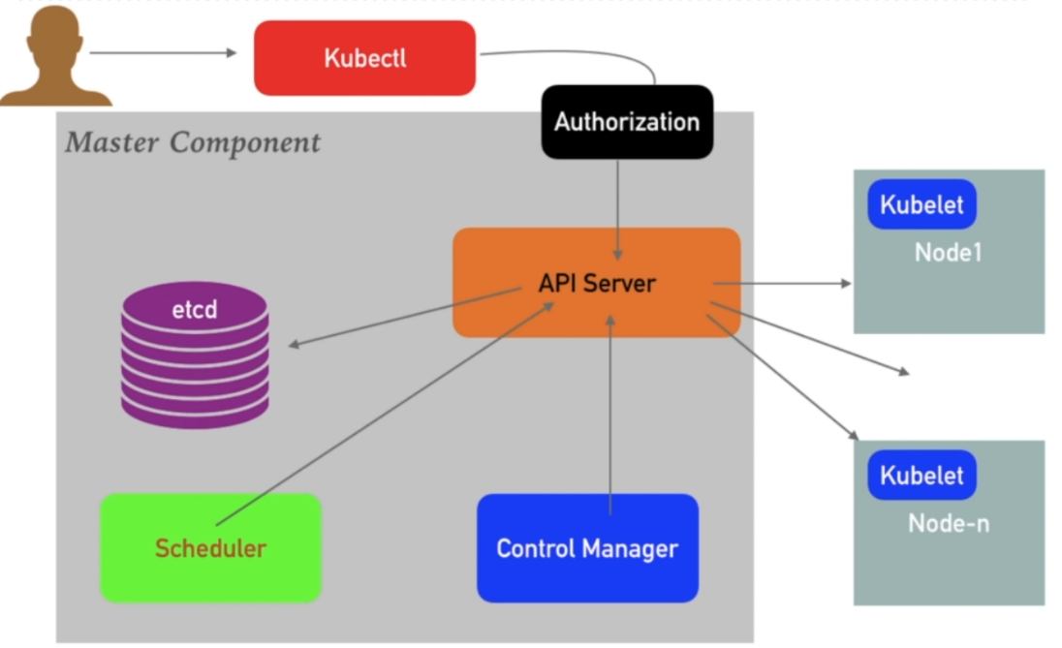In Kubernetes, **Resource Quotas** are limits set on the amount of CPU, memory, storage, and other resources that can be used within a particular **namespace**. A **namespace** is like a separate environment or project within a Kubernetes cluster. Resource quotas help prevent a single application or user from using up all the cluster’s resources, ensuring fair sharing between different teams or projects.

**RBAC (Role-Based Access Control)** in Kubernetes is a way to manage who can do what in a Kubernetes cluster. It lets you set rules that define what actions users or services can perform on different resources like Pods, Services, or Deployments. There are three key parts: **Roles**, which define what actions are allowed (like reading or creating resources); **RoleBindings**, which link those roles to users or services; and **ClusterRoles**, which are similar but apply across the entire cluster. RBAC helps ensure that only the right people or services can access or modify certain resources, keeping your cluster secure and organized.